

Power BI for Office 365

Overview Demo Presenter Guide

This document is provided “as-is”. Information and views expressed in this document, including URL and other Internet Web site references, may change without notice. You bear the risk of using it.

This document does not provide you with any legal rights to any intellectual property in any Microsoft product. You may copy and use this document for your internal, reference purposes.

© 2014 Microsoft. All rights reserved.

# Contents

Contents 3

Setup Instructions 4

Demo Overview 6

Get Started With Power BI 7

Natural Language Queries with Q&A 8

Data Visualization with Power View 10

Data Discovery with Power Query 13

Data Modeling with Power Pivot 16

Geospatial Visualization with Power Map 20

Appendix: Power BI Admin Center 23

Demo Reset Instructions 24

# Setup Instructions

**Before You Begin**

1. To access your demo environment, first obtain login information for your online tenant. This includes:

* The demo starting site URL (https://<TenantName>.sharepoint.com/sites/powerbidemo), which will be referred to in this script as <SiteCollectionURL>. We recommend that you add this site as a favorite in your browser for easy access.
* The login credentials for the primary demo persona, Garth Fort:
  + User account: [garthf@<TenantName>.onmicrosoft.com](mailto:garthf@%3cTenantName%3e.onmicrosoft.com)
  + Password: pass@word1

1. Confirm that you have the latest versions of Power Query and Power Map for Excel 2013. Power BI for Excel works best with 64-bit.

* Power Query: <http://blogs.msdn.com/b/powerbi/archive/2013/08/29/try-the-latest-power-query-update.aspx>
* Power Map: <http://www.microsoft.com/en-us/download/details.aspx?id=38395>

**These are steps to be performed prior to each demo execution.**

1. Navigate to https://<TenantName>.sharepoint.com/sites/powerbidemo
2. Log into Yammer feed by clicking on the house icon.
3. Type<TenantName> when prompted for network / pass@word1

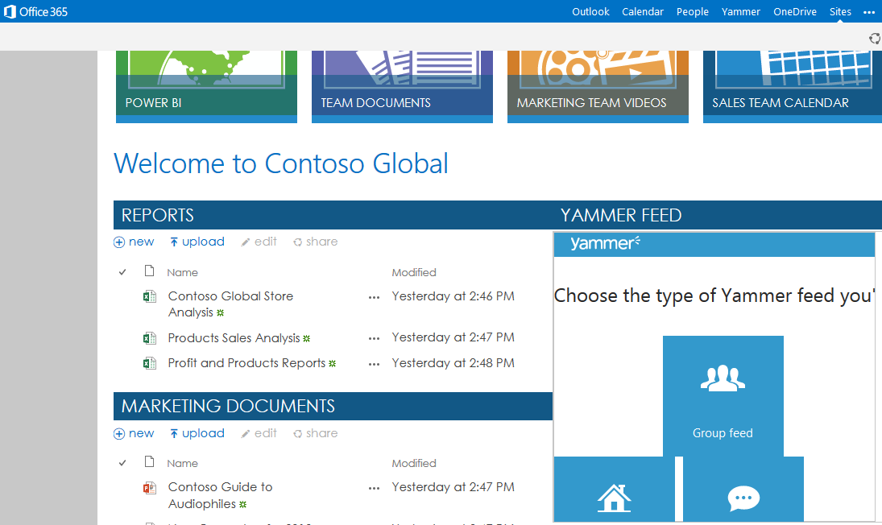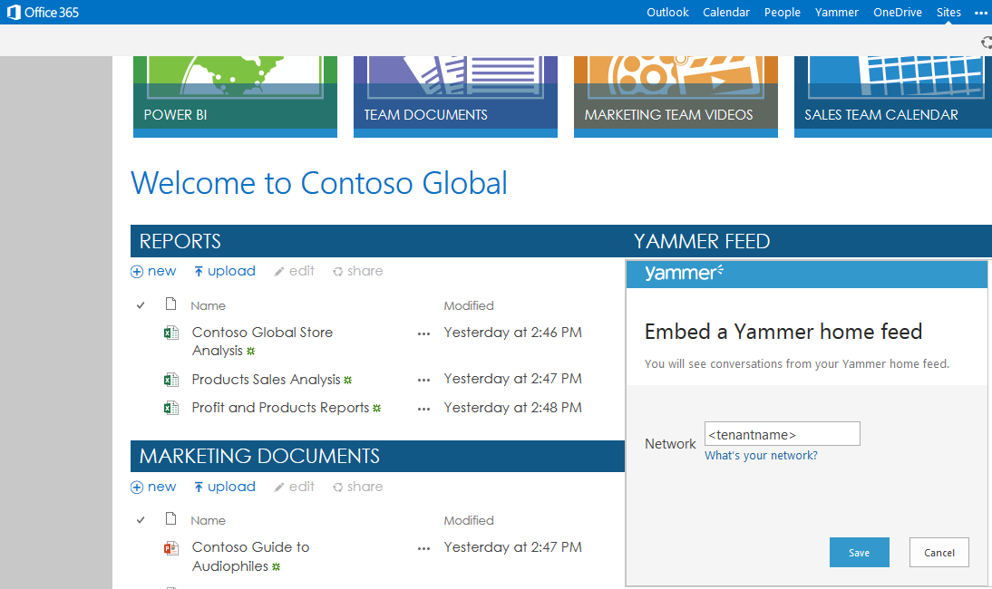

1. If you expect slow network connectivity, we recommend you download the workbook **Contoso Global Store Analysis.xlsx** from the Documents section of Power BI, to the desktop beforehand.

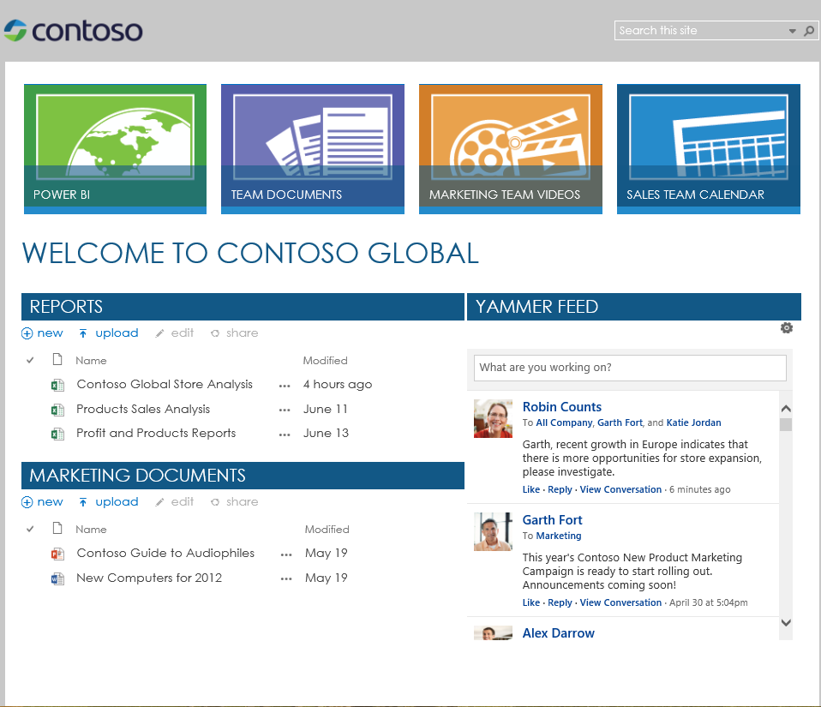 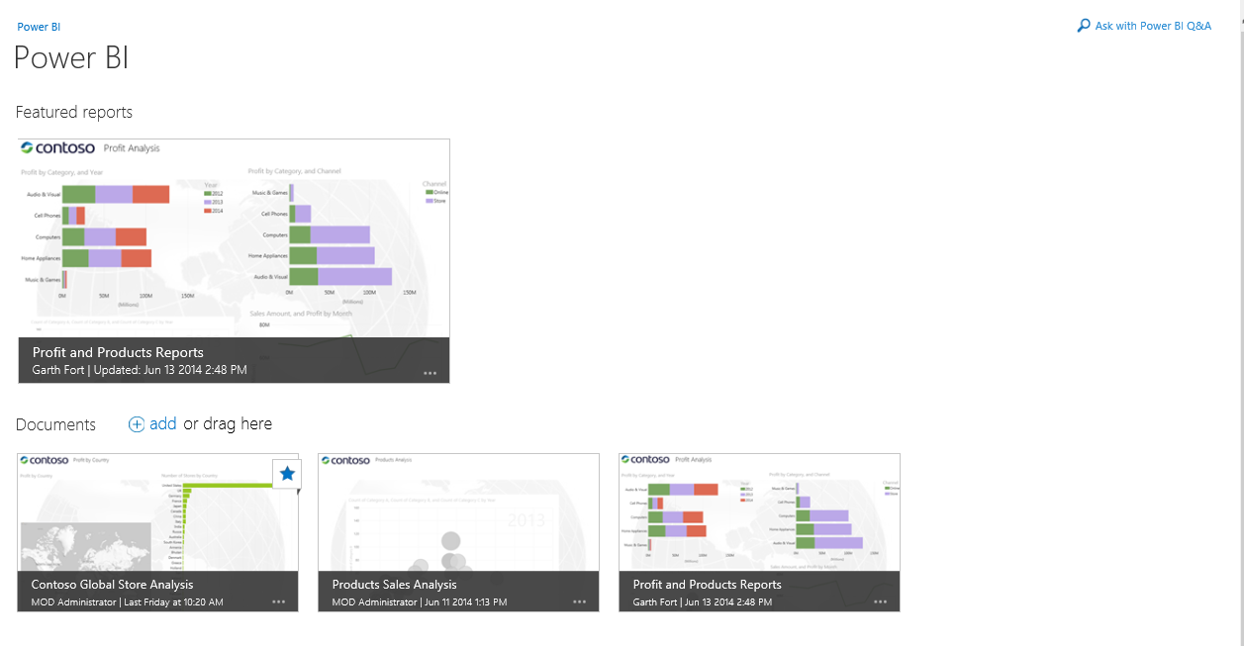

# Demo Overview

**Intended Audience**

Information Workers, Power Users, Business Decision Makers and IT Professionals

**Goals**

The goal of this demo is to provide an overview of Power BI in Office 365. The script will cover the functionality and purpose behind the most compelling Power BI features.

**Scenario**

Contoso Consumer Retail is fast becoming a household name in electronic products. The company is a well-established electronics product store in the U.S.A. They want to expand their business into a new region, particularly Europe and its recent growth opportunities.

In this demo, we will showcase how Garth Fort uses Power BI to analyze data and discover new insights, as the Global Operations Manager at Contoso.

# Get Started With Power BI

| **Speaker Script** | **Steps** |
| --- | --- |
| As the Global Operations Manager at Contoso, I am able to get access to real time, interactive BI reports from my company’s Power BI for Office 365 site. As I log in to the Contoso Global collaboration site I see a Yammer post from my manager, Robin Counts. He is asking me to do some investigation on which products and which countries Contoso should consider for store expansion.  Power BI gives you the capabilities for quick investigation analysis as well as deliver professional reports based on the newly discovered insights. | 1. Navigate to Power BI by clicking **Sites** from the **Office 365 App Launcher** () in the upper left, and then clicking the Power BI site in the middle of the page in **Sites I’m following**, or type in the URL directly: https://<TenantName>.sharepoint.com/sites/powerbidemo      1. Read the Yammer feed from Robin Counts. 2. Click the **Power BI** tile located in the upper left. |

# Natural Language Queries with Q&A

| **Speaker Script** | **Steps** |
| --- | --- |
| I want to look up what products are doing well at Contoso, and where they are successful. For this I can use the new natural language query tool, **Q&A,** for quick investigation to find where our products are doing well and where we have opportunities.  You will notice that Q&A selects a map view for me based on the underlying data type.  I can see that **Audio & Visual** is doing well, but where? By simply adding ‘country’ to the query, Q&A renders the new insights in the chart that makes the most sense, in this case a map chart.  I can quickly observe that the U.S. is our largest market, but is also saturated with stores, while Europe seems like the best fit for Contoso’s new store expansions. | 1. Navigate to the upper right corner of the Power BI page. 2. Click the magnifying glass **Ask with Power BI Q&A**.      1. Hide the ‘About this Data’ tab if it opens. 2. Type **Profit by Category** in the question bar. Notice the bar *chart that displays.* 3. Append: Profit by Category **and Country.** Notice the chart changes to a map chart. 4. Click **‘Enable Content’** in the warning bar. Hide filters for more screen real estate if needed. |

# Data Visualization with Power View

| **Speaker Script** | **Steps** |
| --- | --- |
| To get more details, let’s start our analysis with the Global Store workbook in Power BI for Office 365.  Power BI Sites allow me to enable Power BI reports to Q&A, schedule data refreshes, and add reports as Featured Reports to Power BI. By promoting reports to Featured Reports, I can easily share insights with my team. | 1. Navigate back to **Power BI** by clicking on the back arrow next to the question bar. 2. Find the **Contoso Global Store Analysis** report located in the **Documents** section of Power BI. 3. Click the **ellipsis** (…) for that report. 4. Click **Add to** **Featured Reports**. |
| The upper left chart “**Profit by Category, and Year**” in the Store Sales Analysis tab reconfirms that Audio & Visual is doing well, but I want to drill down further.  My Power View chart has the ability to drill down into the data.  I can double-click anywhere in the Audio & Visual bar chart and see the sub-categories. My report shows that Camcorders have been very profitable over all other sub categories. You will see that the other charts update as well.  The chart below shows Profit, Sales Amount and Sales Quantity by Category trending over the year. By using the play button, or manually moving the Month scroll bar, I am able to scan across the time trends to see the changes in profit that Camcorders have made throughout the year.  This confirms that we should focus our expansion stores with Audio and Visual products to ensure quick market success.  Now that I know our best products, I now want to switch my focus to see which countries would be a good fit for store expansions.  Let’s go to the next sheet in the workbook **Profit by Country**. This report shows **Profit and Sales Amount by Country** with a map view, and a bar chart showing country and number of stores. I can see right away the among the European countries, the U.K. and Germany are already saturated with many stores. | 1. Click the new featured report ‘**Contoso Global Store Analysis’** 2. Double click the **Audio & Visual** bar in the upper left chart.      1. Click the Play button in the Sales Amount, Profit, and Overall Margin by Sub Category chart below.      1. Navigate to the **Profit by Country** tab below. |

# Data Discovery with Power Query

| **Speaker Script** | **Steps** |
| --- | --- |
| I want to focus on countries with less than two stores and find cities with populations large enough to support Contoso’s expansion.  To find this, I’ll use **Power Query** to search for public data about population to support my analysis.  Power Query’s online search feature has the ability to search for external and internal data and import it into my report.  We will now open the report in the rich Excel client to use its full capabilities for data access, modeling and to create beautiful geospatial tours for our conclusion.  By adding European population data, we are able to identify that Spain is the best country to expand, due to its relatively low number of stores and high population. | 1. Press the browser’s back button. 2. Select the ellipses beside the Contoso Global Store Analysis report in the **Documents** (and not the Featured Reports) section, and click ‘**Edit in Excel**’.      1. Login with garthf’s credentials if prompted, and click ‘**Edit Workbook**’ in the top navigation. 2. Click **No** if **Do you want to make this file a Trusted Document Security Warning** displays. 3. In the ribbon, click the **Power Query** tab. 4. Click **Online Search**. 5. Type **European Population** in the search box and press ENTER**.** 6. Hover over the report in the search result ‘**Cities over 300,000 inhabitants - Largest cities of the European Union by population”.** 7. Click **Load** on bottom left of preview screen.      1. See the screen shot below for reference. |

# Data Modeling with Power Pivot

| **Speaker Script** | **Steps** |
| --- | --- |
| Once I have loaded the new data, I can now add it into the existing data model and create a relationship to merge them together.  Let’s define new relationships by going to the **Diagram View** in the top menu bar under Home. Defining relationships is fairly easy simply by dragging and dropping related fields. By pausing on the linked arrows, I know that my relationships have been properly linked.  Next, I want to make sure my new data can be searched more accurately in Q&A. I do this by adding new synonyms to the table, which allows Q&A to identify which terms should have identical meaning for queries. | 1. In the ribbon, click the **PowerPivot** tab, and then click **Add to Data Model**. 2. Click **Diagram View** on the far right side. 3. Drag and drop the **City** field from thenewly imported **Cities** table, to the corresponding **City** field in the **Store** table.        1. In the PowerPivot for Excel ribbon, click the **Advanced** tab. 2. Click **Synonyms**. 3. Add **Country** next to **State**. 4. Click **Synonyms**. 5. Add **Country** next to **State**.      1. Click **X** at the top right of window to close PowerPivot for Exceland go back to the Excel client. |

# Geospatial Visualization with Power Map

| **Speaker Script** | **Steps** |
| --- | --- |
| I have analyzed that the U.K. and Germany are not viable expansion areas, and that Spain would be a good candidate for the next European expansion. I can add my new data to an existing Power Map tour.  By adding the new data population into my Power Map scenes, I can show that which cities have the population to support Contoso’s stores and the right market fit for Contoso’s products.  With the new Power Map tour, I can finally present in a 3 dimensional geospatial map, that Madrid and Barcelona would be the best cities to expand our stores in Europe. | 1. In the ribbon, click the **Insert** tab. 2. Click **Map**. 3. Click **Worldwide Sales (before)**. 4. Click the third scene **Spain Store Expansion**. 5. Select **Add Layer** from the ribbon. 6. Check the **City** fieldfrom the **Cities_over_300_000_inhabitants_Largest_cities_of_the_European_Union_by_population** section**.**      1. Click **Next**. 2. Click **Official population (actual)** to send it to the **Height** section. 3. Select **Heat Map** for visualization. The icons are above the **Height** heading.      1. In the ribbon, click **Find Location.** 2. Type **Spain** and then click **Find**. 3. Click **Play Tour** to preview. 4. Exit tour and close worksheet without saving changes. 5. See the screen shot below for reference. |

# Appendix: Power BI Admin Center

| **Speaker Script** | **Steps** |
| --- | --- |
| The Power BI Admin Center enables Admins to manage the Power BI service.  Click <http://office.microsoft.com/en-us/office365-sharepoint-online-enterprise-help/power-bi-for-office-365-admin-center-help-HA104078330.aspx> to read more about the Admin Center. | 1. Navigate to https://<SiteName>.sharepoint.com/sites/powerbidemo 2. Login as **admin@<tenant>.onmicrosoft.com**. |
| From the Power BI admin center, administrators can manage system health, data sources, data management, role management, and settings from an all-up site collection service.  Click <http://office.microsoft.com/en-us/office365-sharepoint-online-enterprise-help/create-a-data-management-gateway-HA104093659.aspx> read more about the Data Management Gateway.  The gateway feature is ideal for organizations requiring connections to on premise data sources in their corporate environment.  Windows 8 users can download the Power BI Mobile App to view data from their mobile devices. | 1. Click **Admin** from the **Office 365 App Launcher** (). 2. Navigate to **Power BI**. 3. Click **Power BI**. 4. Download Power BI app from Windows app marketplace. |

# Demo Reset Instructions

1. Remove **Contoso Global Store Analysis** from **Featured reports** section of the **Power BI** page in your SharePoint site.